JIRA SOFTWARE

Example: Hospital management system

Dashboard: Roadmap

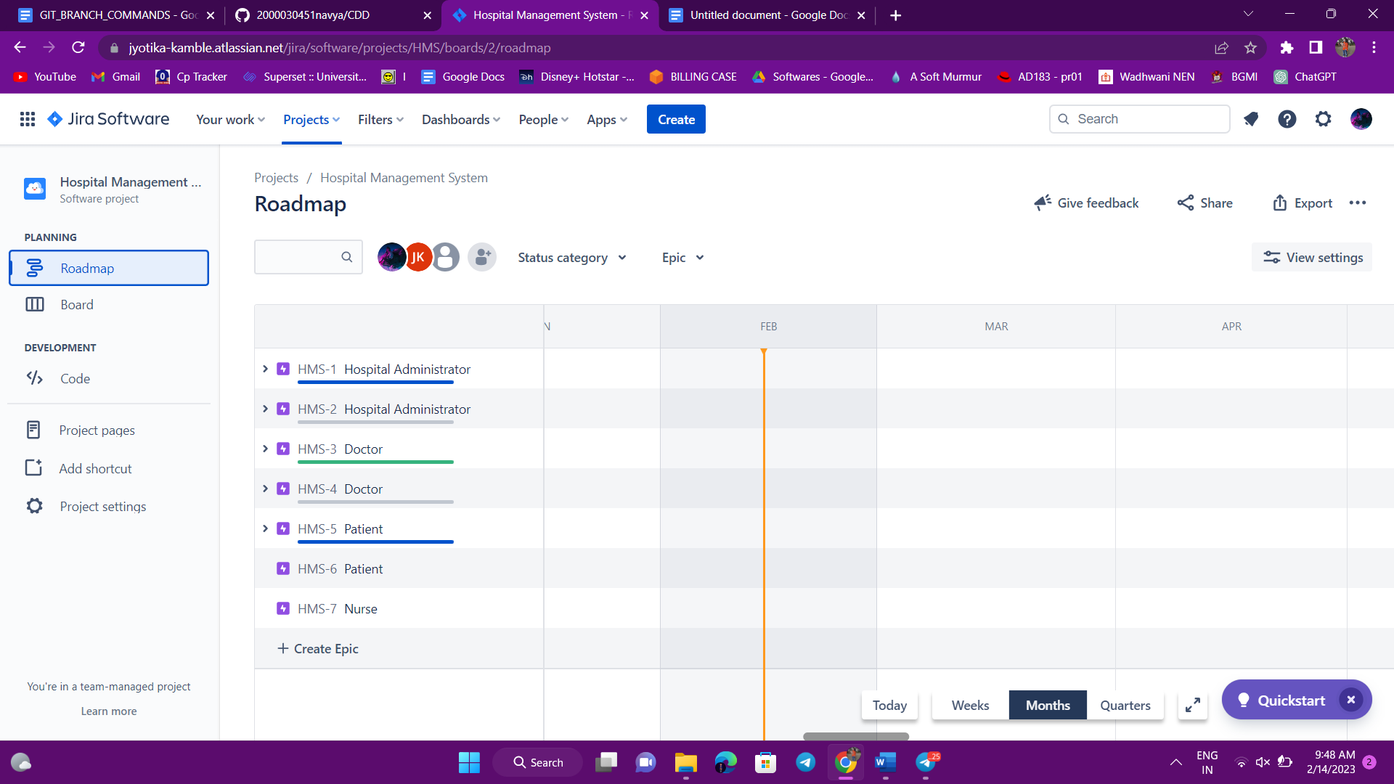

Board:

